# QUICK GUIDE SIYI FPV SDK

## Add “fpvlib” as dependency to your project

For example the content structure in “demo” is like below:

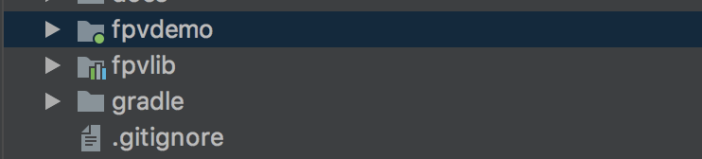

Add it as dependency in the file “build.gradle”;

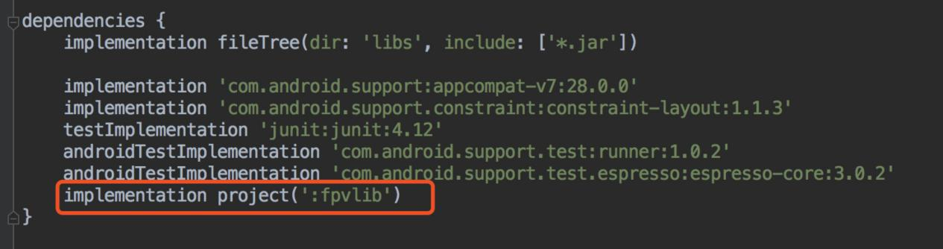

## Configure the file “Android Manifest”

In your module, add USB reading authority to configure intent-filter in “Android Manifest”.

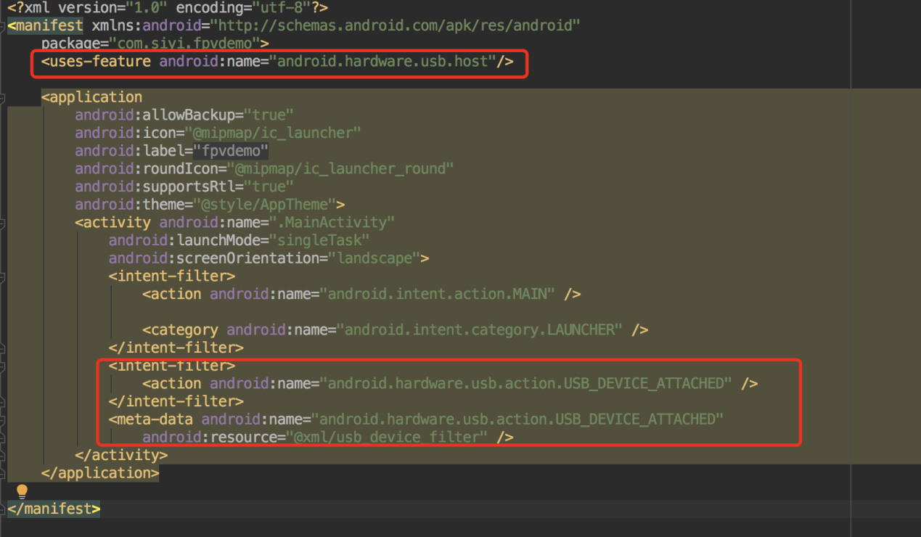

## Add FPV display function into your code

1. **Add JNI Library**

Add “JNILibs” files into content “main” as below

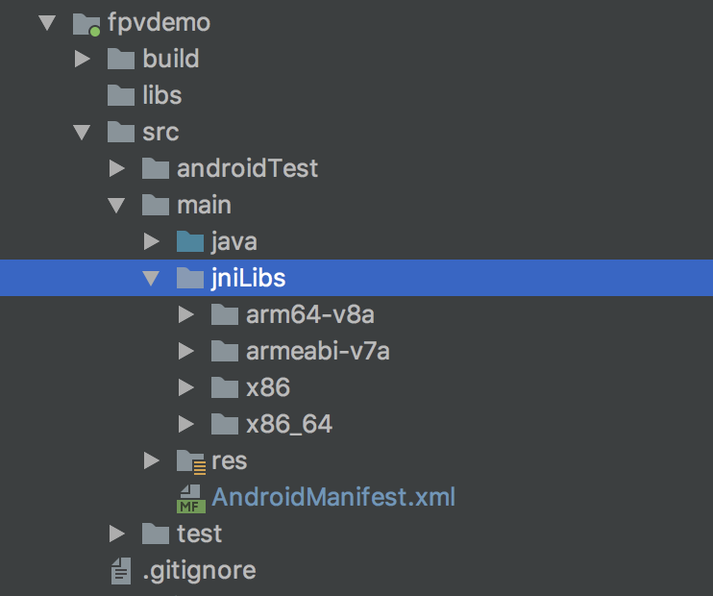

1. **Display FPV in your code**

Pay an attention to several points below in your code:

1. Get “UsbConnectionManager” object using static method “getlnstances” of “UsbConnectionManager”.
2. Then check if USB can be connected using steps below:

*/**  
 * 判断USB连接状态  
 */*private void checkUsbConnectState() {  
 UsbManager usbManager = (UsbManager) getSystemService(Context.*USB_SERVICE*);  
 HashMap<String, UsbDevice> deviceList = usbManager.getDeviceList();  
 int deviceCount = deviceList.size();  
 if (deviceCount > 0) {  
 for (UsbDevice device : deviceList.values()) {  
 if (DriverUtil.*isStm32Device*(device)) {  
 mUsbConnectionManager.onUsbAttached(device);  
 break;  
 }  
 }  
 } else {  
 Logcat.*d*(*TAG*, "no usb device attached");  
 }  
}

1. FPV will be displayed through “SurfaceView”, so you need to create an object of SurfaceView, and to call UsbConntionManager.onSurfaceCreate() method and onSurfaceDestroy() method between “surfaceCreated()” and “surfaceDestroy()”.
2. **When you are to quit the application, please do not forget to call “UsbConnectionManager.release()” method.**

**For more detail please refer to the codes in demo.**